**Kitchen Story**

Github project link: <https://github.com/JoswinDsouza99/Simplilearn-hase4/tree/main/Kitchen%20Story>

The sign up page for the user he can add all the necessary details and later sign in into the application

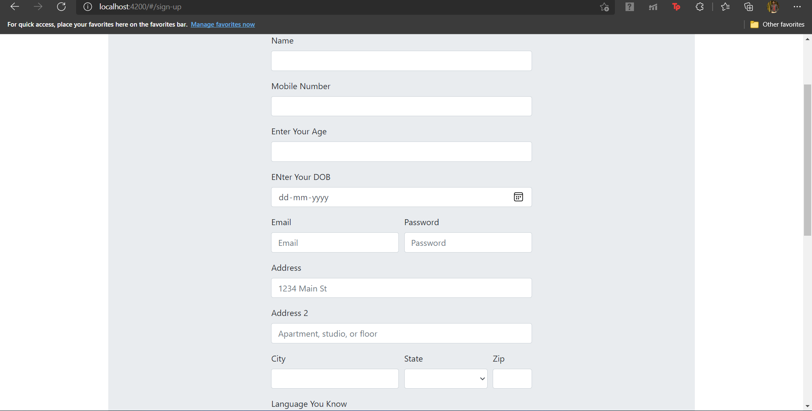

The Sign in page for the user where he can login using his email and password credentials. Proper Validation has been put up.

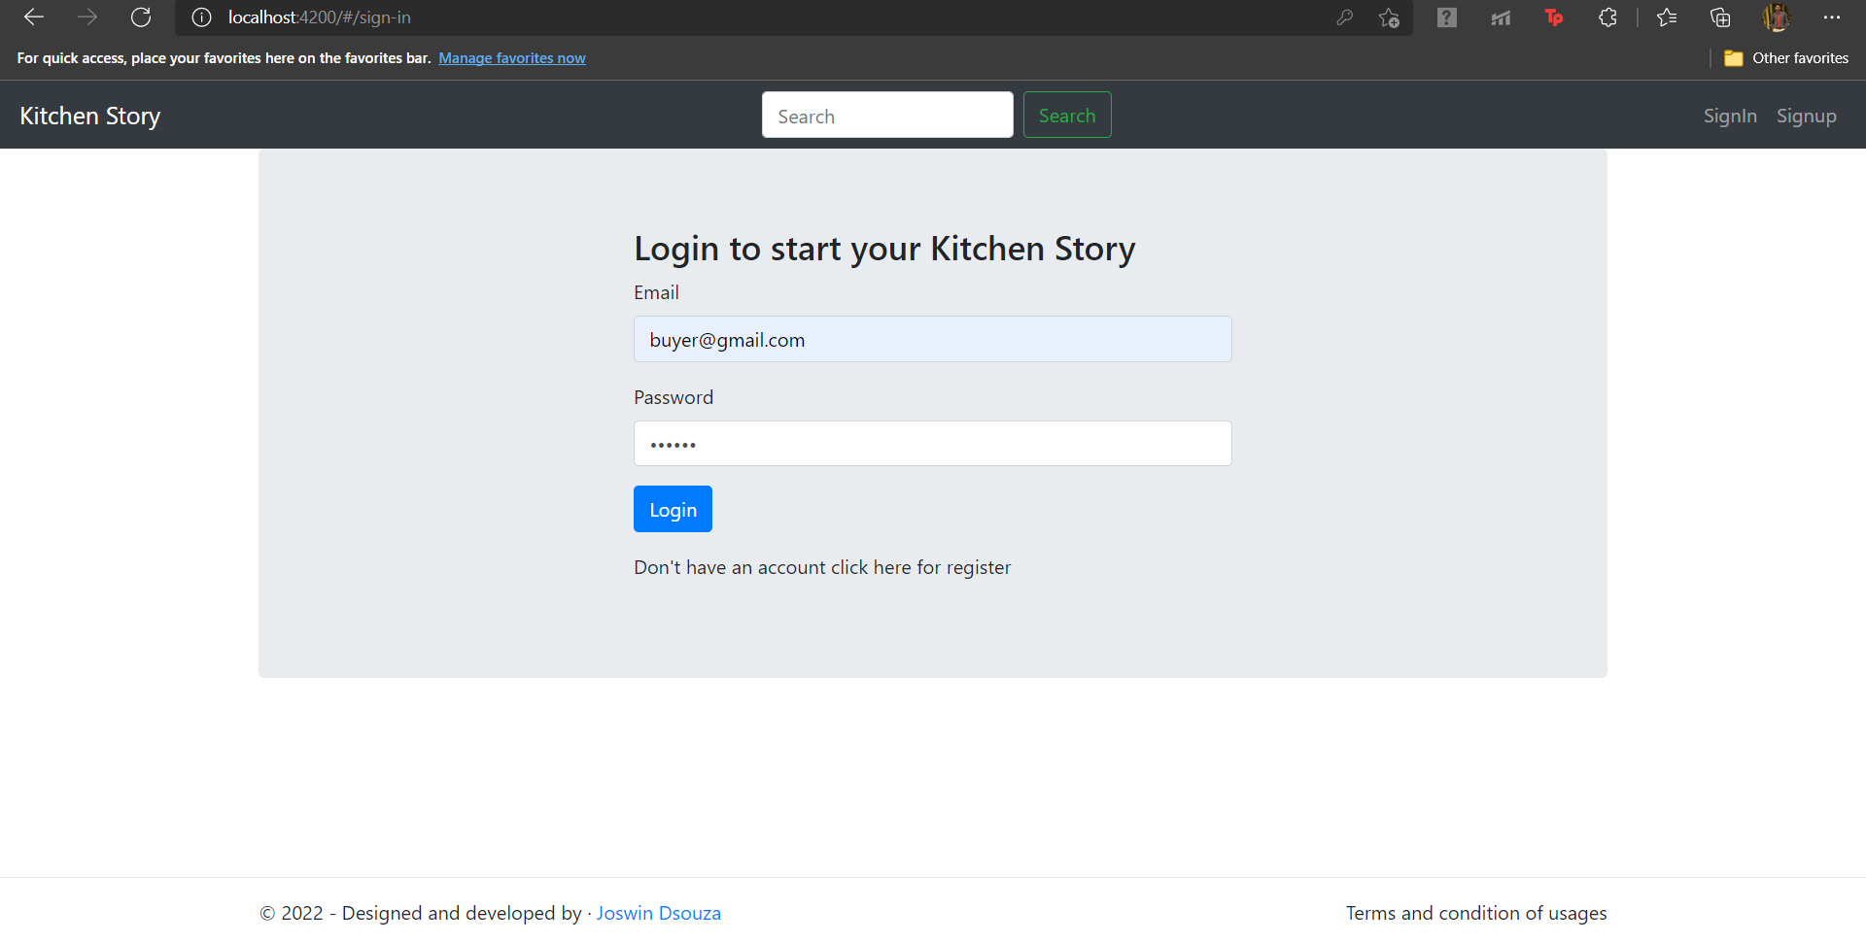

Once the user logs in he can view the different products available in Kitchen story and later he can search and buy them

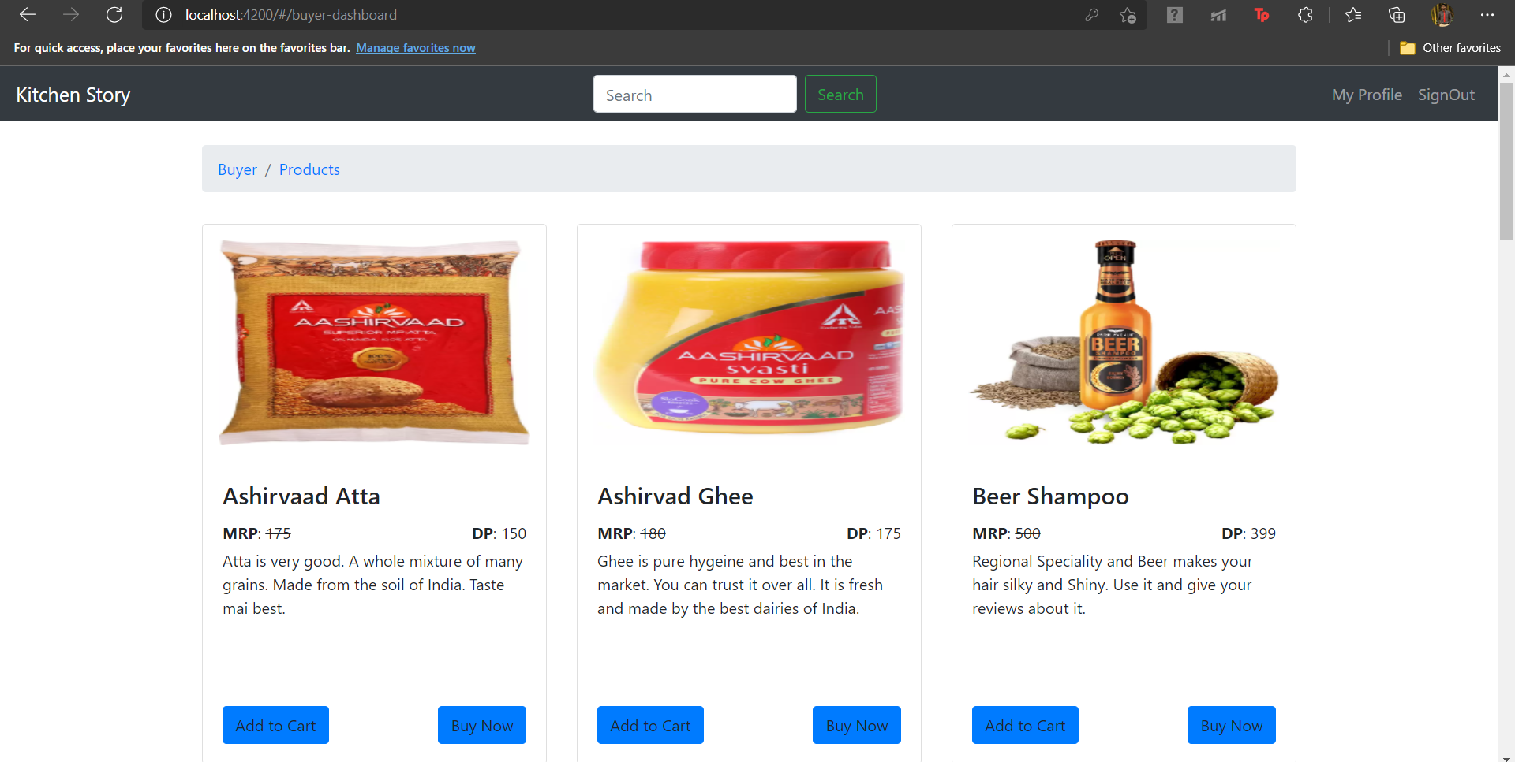

Once he adds into the cart he can view it and confirm the order

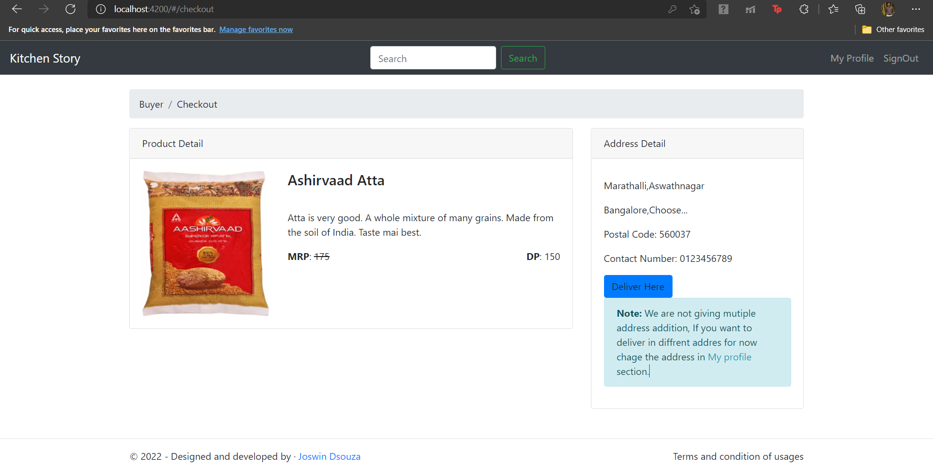

This is the admin login

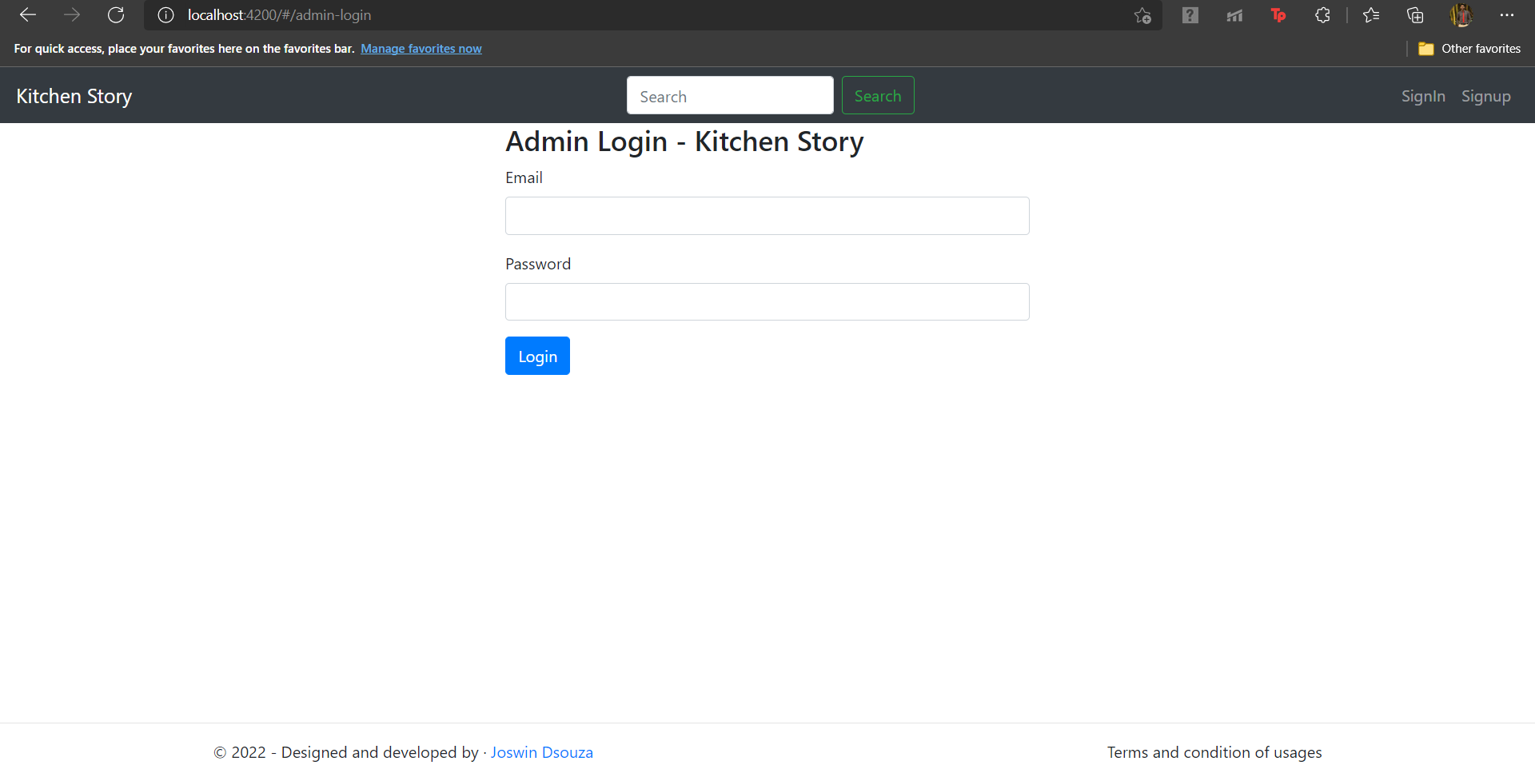

This is the admin dashboard where he can manage the users and the products available

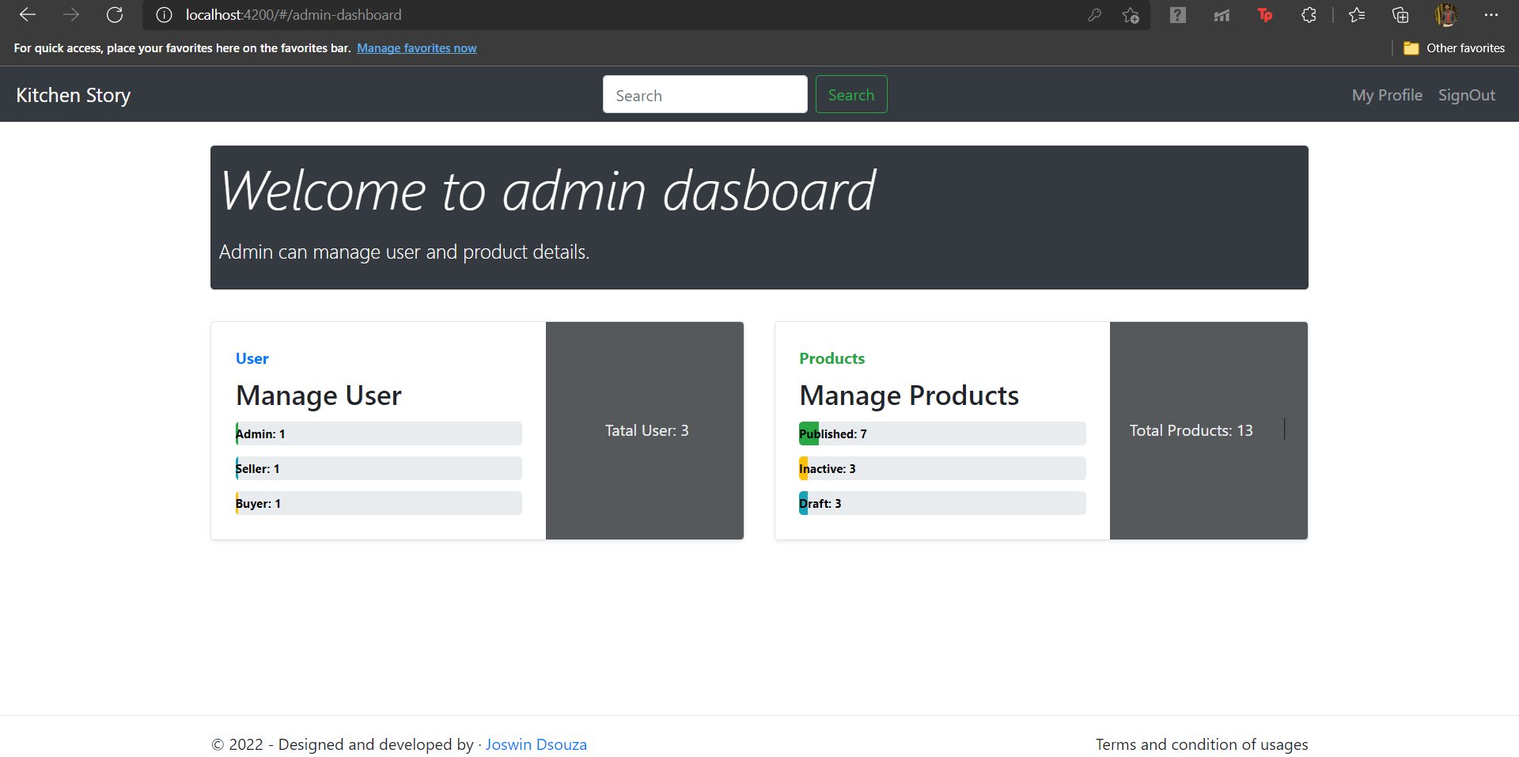

The admin also has the right to edit the orders add them and even delete and we can see below

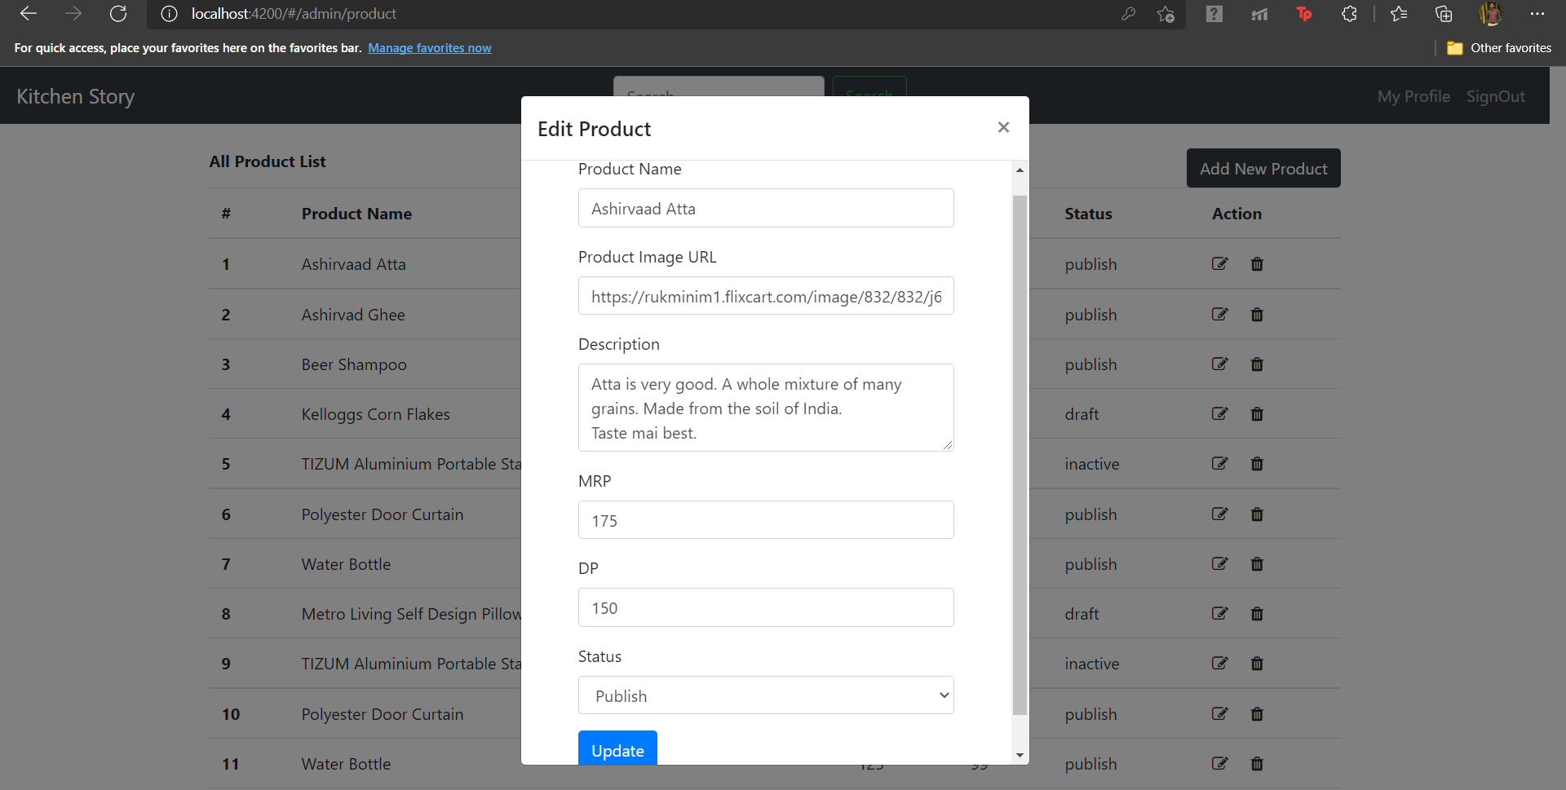

We can see that the details are being stored and fetched through the Json file

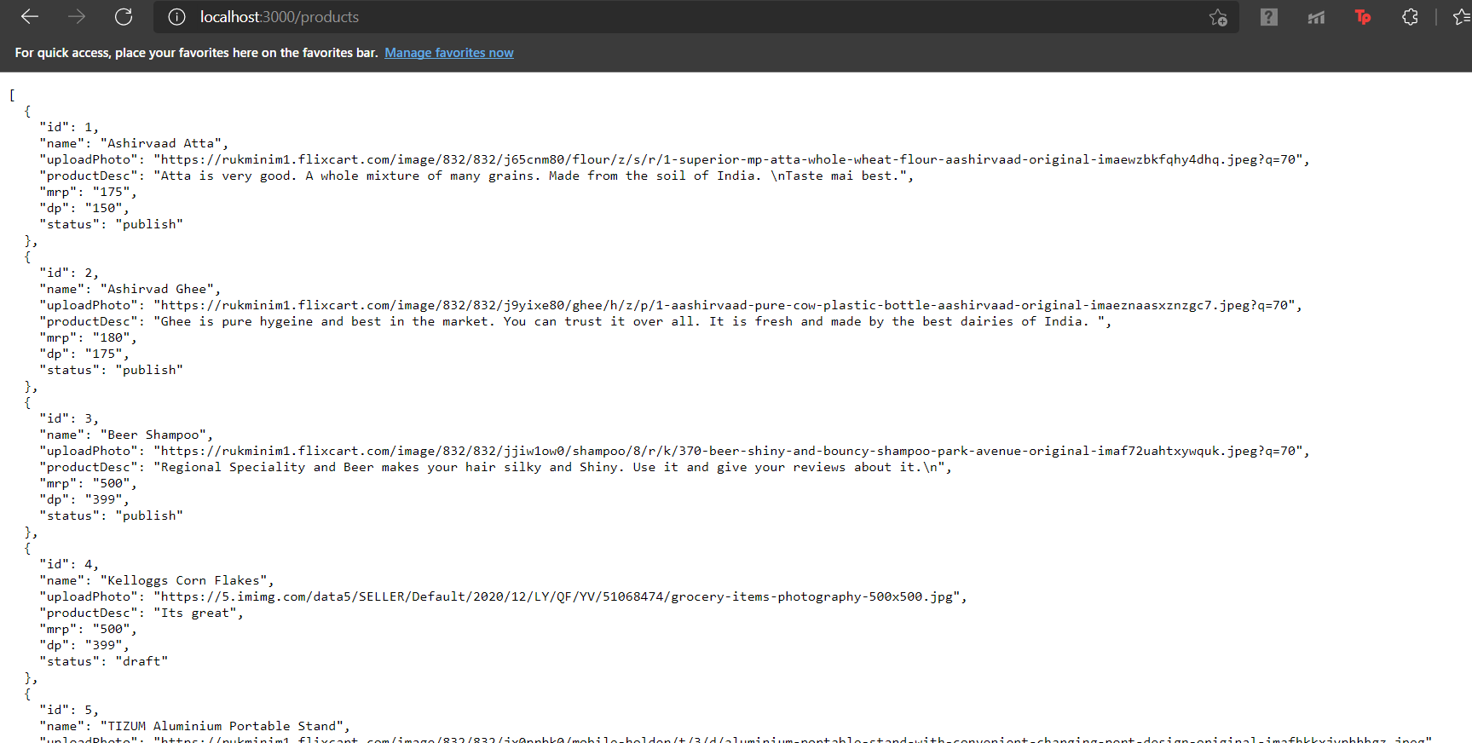

**Inference:**

Understanding of front end developer and how to make effective applications. Use of bootstrap, typescript, javascript and Angular. How to use node and proper usage of them.

How to build applications using all of them and how it is connected.